<Hongyi Zhu>

<2021-11-26>

<IT FDN 110>

<Assignment_Module_07>

Working with Text Files and Structured Error Handling

# Introduction

In this module, we learned how to work with text files using python. The basic commands are to open, write, read, and close the text files. We can also append the sentences into the existing file and read the specific lines using loops. The with…as option is another useful and convenient way to work with the text files without the need to write the close command. Aside from that, we can save binary information with the pickle module. The other concept here is the structured error handling. We can use the try-except structured error handling construct to handle the basic error situations. Besides these automatically generated errors, it is also useful to raise errors of custom conditions.

# Topic 1

I used [Syntax Highlighter](https://highlight.hohli.com/index.php) (external reference)[1] web page to highlight the script as shown in Listing 1 and highlighted what I revised/added in the example solution. In this topic, I read the solution example and understood the coding logic. What I did is to use the “try-except” block to handle some errors that may occur when the user does the input and open the file:

Notes:

1. Line 43-47:

This part tells the user to open a file in the reading mode. If the file gets removed or does not exist at all, then the “FileNotFound” error will occur and the program will return to menu. So, I used the “try-except” block to avoid the program going crashed.

1. Line 49-56:

In the first column of CDInventory.txt text file, if the ID number here is not an integer, Line 51 'ID': int(data[0]) will have the “ValueError” and the “try-except” construction can handle the error and print “invalid line, please modify the ID as integer”, then return to menu.

1. Line 93-100:

This part tells the user to input an integer as ID. And if the user’s input is not an integer, then it is a “ValueError” and will print out “invalid input” and does not terminate the program. So, I used the “try-exception” block to deal with this situation. Until the user inputs an integer, the program will jump out of the loop and continue to the next step.

1. Line 138-144:

When an ID is to be deleted, if the input is not an integer, line 141 “intIDDel = int(strIDDel)” will occur the “ValueError” and the “try-except” block will handle the error, printing “your input is not an integer”.

And here is the listing of the script, I also highlighted what I revised/added in the listing below:

1. # -- DATA -- #
3. strChoice = '' # User input
4. lstTbl = []  # list of lists to hold data
5. dicRow = {}  # list of data row
6. strFileName = 'CDInventory.txt'  # data storage file
7. objFile = None  # file object
9. # -- PROCESSING -- #
11. class DataProcessor:
13. @staticmethod
14. def add_item(ID, Title, Artist, table):
15. dic = {'ID': ID, 'Title': Title, 'Artist': Artist}
16. table.append(dic)
17. return table
19. @staticmethod
20. def delete_item(table,IDDel):
22. intRowNr = -1
23. blnCDRemoved = False
24. for row in table:
25. intRowNr += 1
26. if row['ID'] == IDDel:
27. del table[intRowNr]
28. blnCDRemoved = True
29. break
31. if blnCDRemoved:
32. print('The CD was removed')
33. else:
34. print('Could not find this CD!')
35. return table
37. class FileProcessor:
39. @staticmethod
40. def read_file(file_name, table):
41. table.clear()  # this clears existing data and allows to load data from file
42. try:
43. objFile = open(file_name, 'r')
44. except:
45. print('invalid filename')
46. return
47. for line in objFile:
48. try:
49. data = line.strip().split(',')
50. dicRow = {'ID': int(data[0]), 'Title': data[1], 'Artist': data[2]}
51. table.append(dicRow)
52. except:
53. print('invalid line, please modify the ID as integer')
54. objFile.close()
55. return
56. objFile.close()
57. @staticmethod
58. def write_file(file_name, table):
60. objFile = open(file_name, 'w')
62. for row in table:
63. lstValues = list(row.values())
64. lstValues[0] = str(lstValues[0])
65. objFile.write(','.join(lstValues) + '\n')
66. objFile.close()
68. class IO:
69. @staticmethod
70. def print_menu():
71. print('Menu\n\n[l] load Inventory from file\n[a] Add CD\n[i] Display Current Inventory')
72. print('[d] delete CD from Inventory\n[s] Save Inventory to file\n[x] exit\n')
74. @staticmethod
75. def menu_choice():
76. choice = ' '
77. while choice not in ['l', 'a', 'i', 'd', 's', 'x']:
78. choice = input('Which operation would you like to perform? [l, a, i, d, s or x]: ').lower().strip()
79. print()  # Add extra space for layout
80. return choice
82. @staticmethod
83. def show_inventory(table):
84. print('======= The Current Inventory: =======')
85. print('ID\tCD Title (by: Artist)\n')
86. for row in table:
87. print('{}\t{} (by:{})'.format(*row.values()))
88. print('======================================')
90. @staticmethod
91. def ask_newID():
92. while True:
93. strID = input('Enter ID: ').strip()
94. try:
95. intID = int(strID)
96. break
97. except ValueError as e:
98. print('invalid input')
99. print(e)
100. strTitle = input('What is the CD\'s title? ').strip()
101. stArtist = input('What is the Artist\'s name? ').strip()
102. return intID, strTitle, stArtist
104. FileProcessor.read_file(strFileName, lstTbl)
106. while True:
107. IO.print_menu()
108. strChoice = IO.menu_choice()
110. if strChoice == 'x':
111. break
113. if strChoice == 'l':
114. print('WARNING: If you continue, all unsaved data will be lost and the Inventory re-loaded from file.')
115. strYesNo = input('type \'yes\' to continue and reload from file. otherwise reload will be canceled')
116. if strYesNo.lower() == 'yes':
117. print('reloading...')
118. FileProcessor.read_file(strFileName, lstTbl)
119. IO.show_inventory(lstTbl)
120. else:
121. input('canceling... Inventory data NOT reloaded. Press [ENTER] to continue to the menu.')
122. IO.show_inventory(lstTbl)
123. continue  # start loop back at top.
125. elif strChoice == 'a':
126. strID, strTitle, stArtist = IO.ask_newID()
127. lstTbl = DataProcessor.add_item(strID, strTitle, stArtist, lstTbl)
128. IO.show_inventory(lstTbl)
129. continue  # start loop back at top.
131. elif strChoice == 'i':
132. IO.show_inventory(lstTbl)
133. continue  # start loop back at top.
135. elif strChoice == 'd':
136. IO.show_inventory(lstTbl)
137. while True:
138. strIDDel = input('Which ID would you like to delete? ').strip()
139. try:
140. intIDDel = int(strIDDel)
141. break
142. except:
143. print('your input is not an integer')
144. lstTbl = DataProcessor.delete_item(lstTbl, intIDDel)
145. IO.show_inventory(lstTbl)
146. continue  # start loop back at top.
148. elif strChoice == 's':
149. IO.show_inventory(lstTbl)
150. strYesNo = input('Save this inventory to file? [y/n] ').strip().lower()
151. if strYesNo == 'y':
152. FileProcessor.write_file(strFileName, lstTbl)
153. else:
154. input('The inventory was NOT saved to file. Press [ENTER] to return to the menu.')
155. continue  # start loop back at top.
157. else:
158. print('General Error')

Listing 1 - Script of Assignment 07

# Topic 2

In this topic, I ran the script and tested all options in spyder.

Figure 1 is the testing result on spyder of [a] adding CD and inputting the wrong ID. When I entered a non-integer, it then turned out “invalid input”. I entered the right integer 4 afterwards and the program continued.

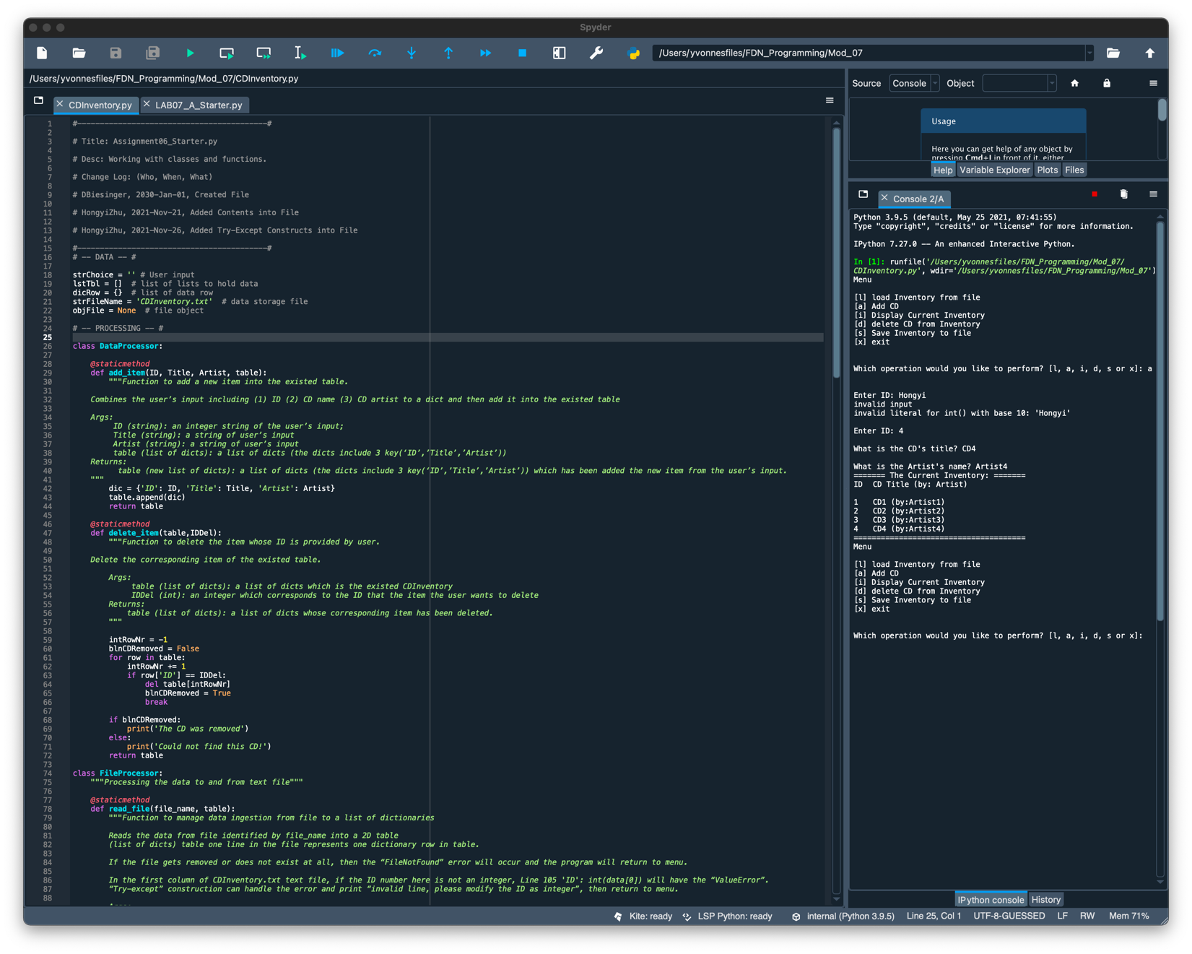

Figure 1 - Running Results of Testing ID Integer in Spyder

Figure 2 is the testing result on spyder of [s] save inventory to file, [i] display current inventory, and [x] exit.

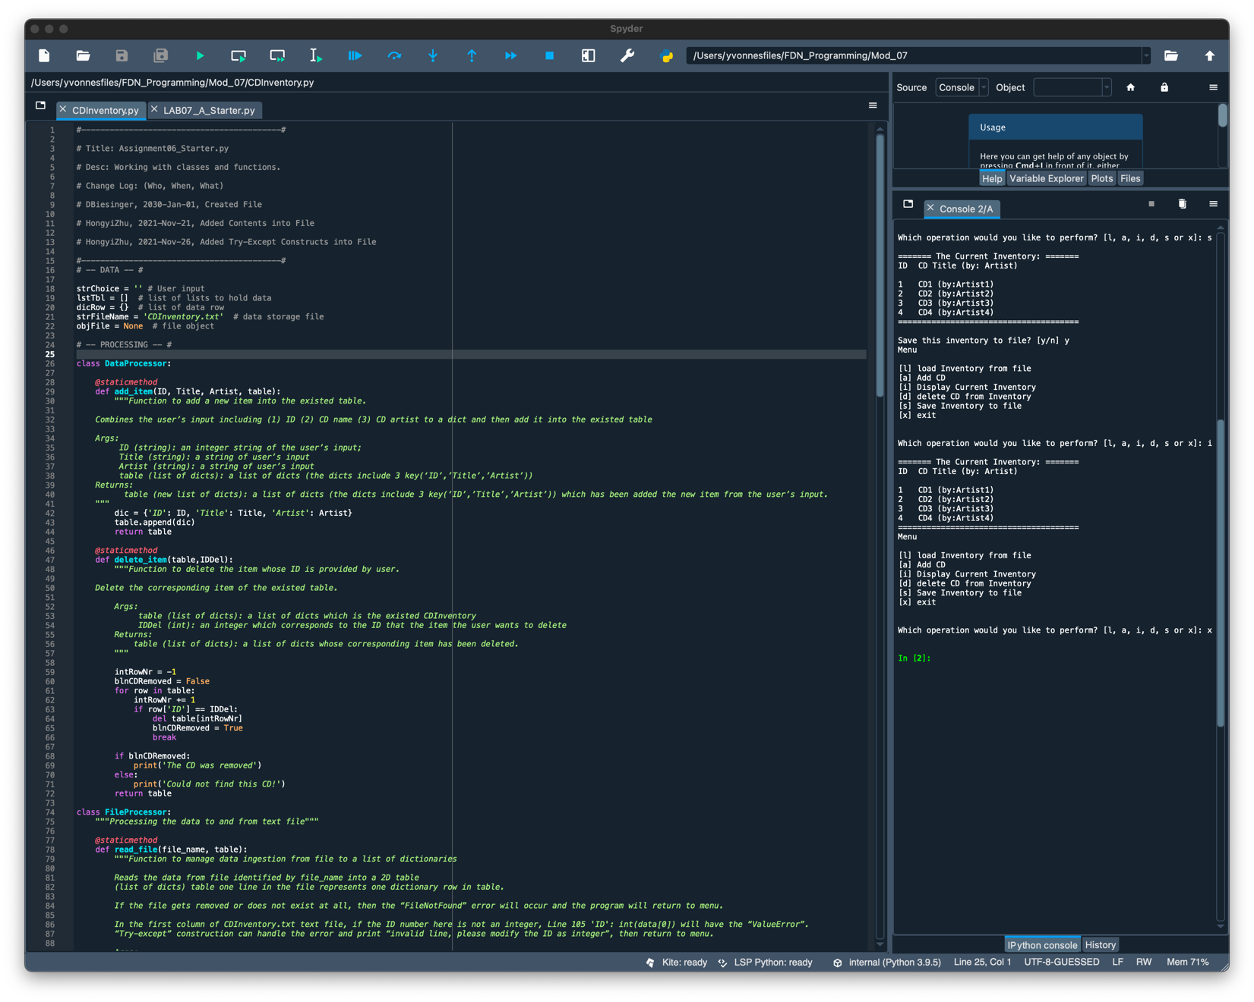

Figure 2 - Running Results of Testing Commands in Spyder

Figure 3 below is the testing result in the text file of adding one line of CD and saving it to file.

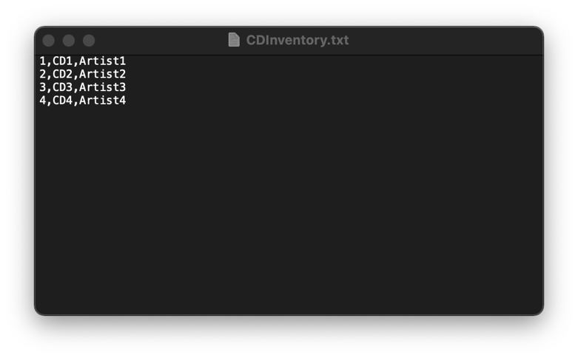

Figure 3 - Testing Results of Adding CD in CDInventory.txt

Figure 4 and 5 first tested [l] load inventory from file, then [d] delete CD from inventory. Besides, when I tried to delete CD from inventory, I did not input an integer to test the “try-except” block in script. When I inputted “Yvonne”, it occurred an error and asked “Which ID would you like to delete?” again until I entered an existing integer. Then I tested [s] save inventory to file and [x] exit.

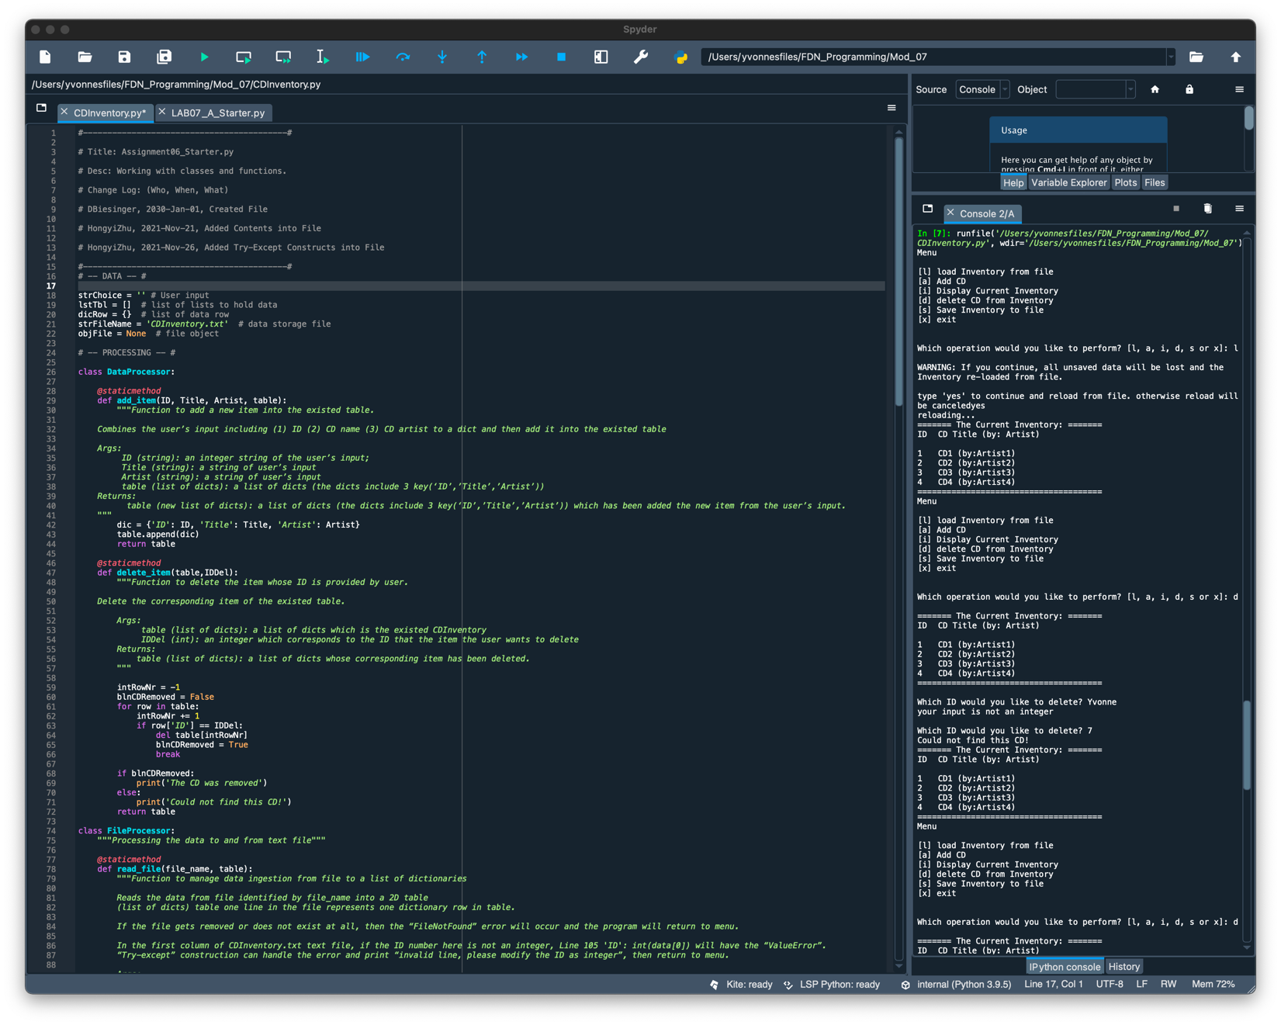

Figure 4 - Running Results of Testing Deleting an Existing CD in Spyder

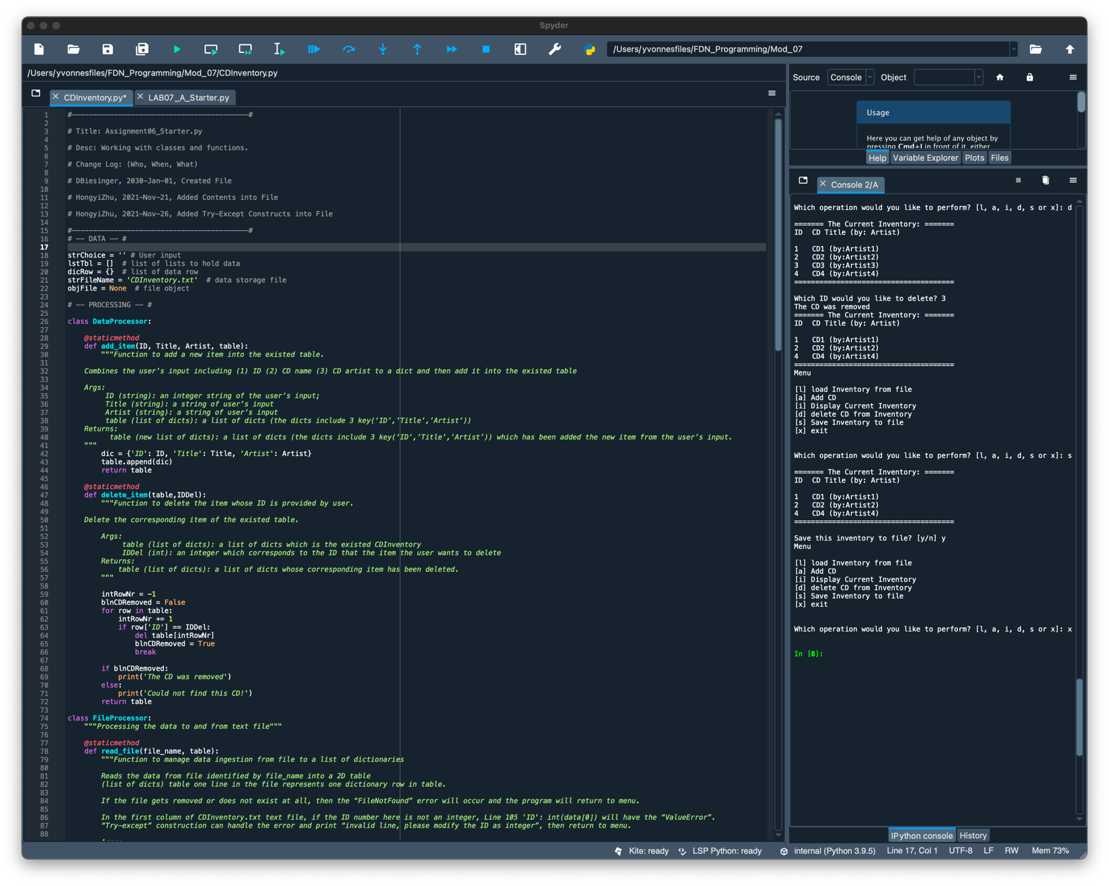

Figure 5 - Running Results of Testing Deleting an Existing CD in Spyder (Continue)

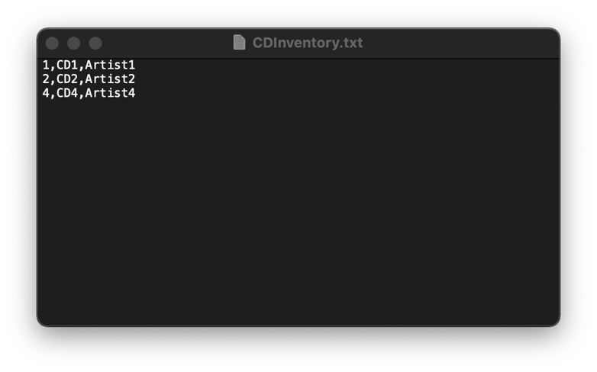

Figure 6 - Testing Results of Deleting CD Shown in CDInventory.txt

I tested the “FileNotFound” error in Figure 7 and 8. I first changed the name of txt file from “CDInventory.txt” to “CDInventory_001.txt”. Then I tried to run the script in spyder and it said “invalid filename” error.

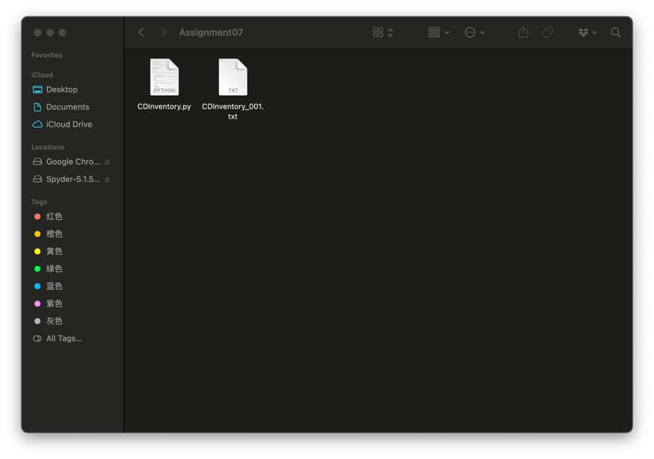

Figure 7 - Changing txt Name in Folder

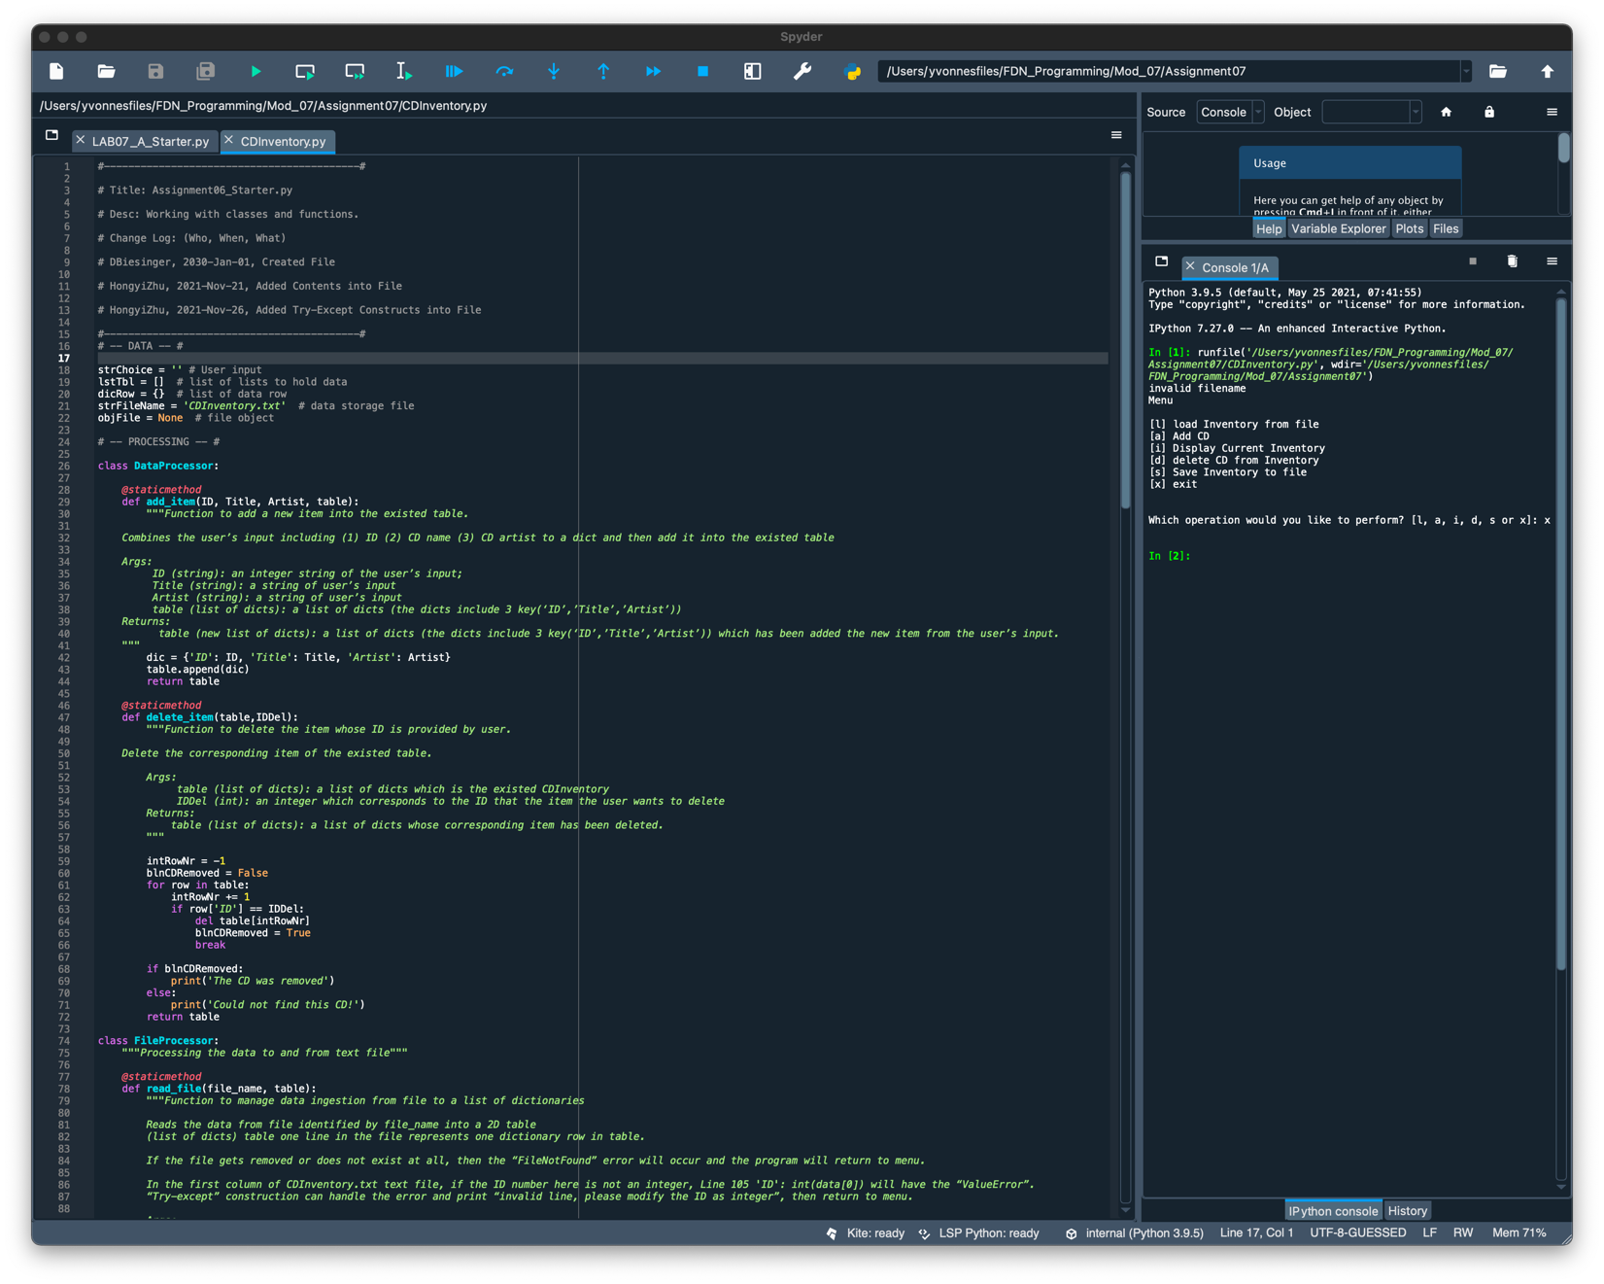

Figure 8 - Testing Results of "FileNotFound" Error in Spyder

I tested the “try-except” construction of Line 49-56 in Figure 9 and 10. I changed the CD number from “4” to “HongyiZhu” in txt file and let it run in spyder. It said “invalid line, please modify the ID as integer” as an error and returned to menu.

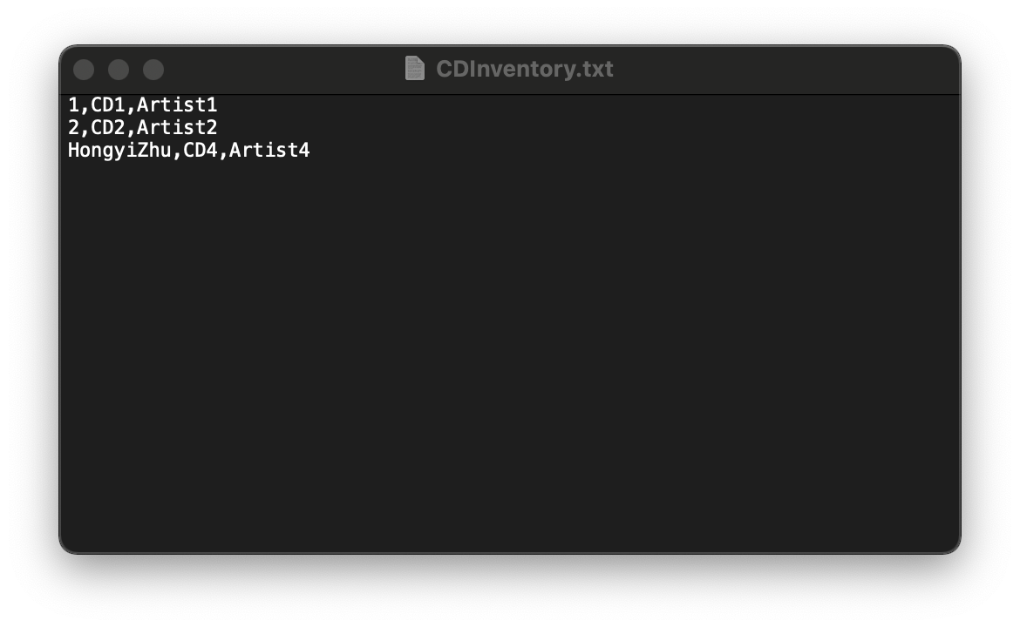

Figure 9 - Changing ID Number in txt

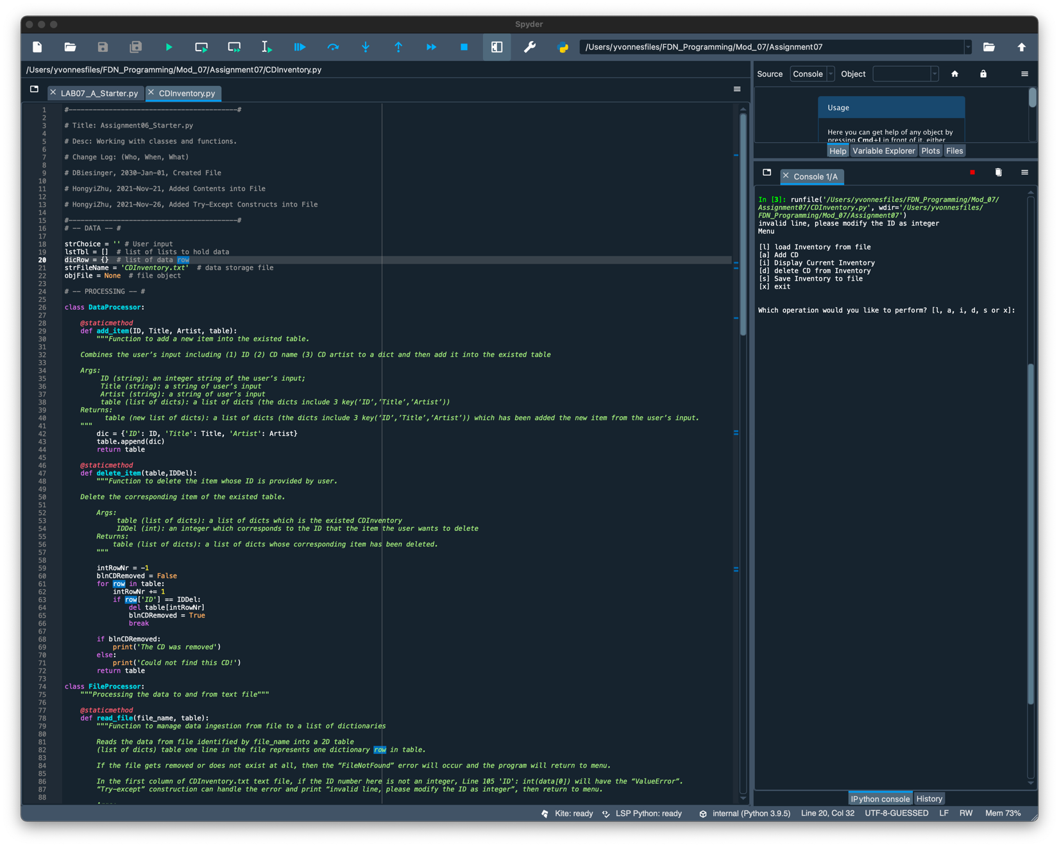

Figure 10 - Testing Results of "ValueError" in Spyder

# Topic 3

In this topic, I repeated all of the same steps in the terminal as what I did exactly in spyder.

Figure 11 is the testing result on spyder of [a] adding CD and inputting the wrong ID. When I entered a non-integer, it then turned out “invalid input”. I entered the right integer 4 afterwards and the program continued. Figure 12 is the testing result in terminal of [s] save inventory to file, [i] display current inventory, and [x] exit.

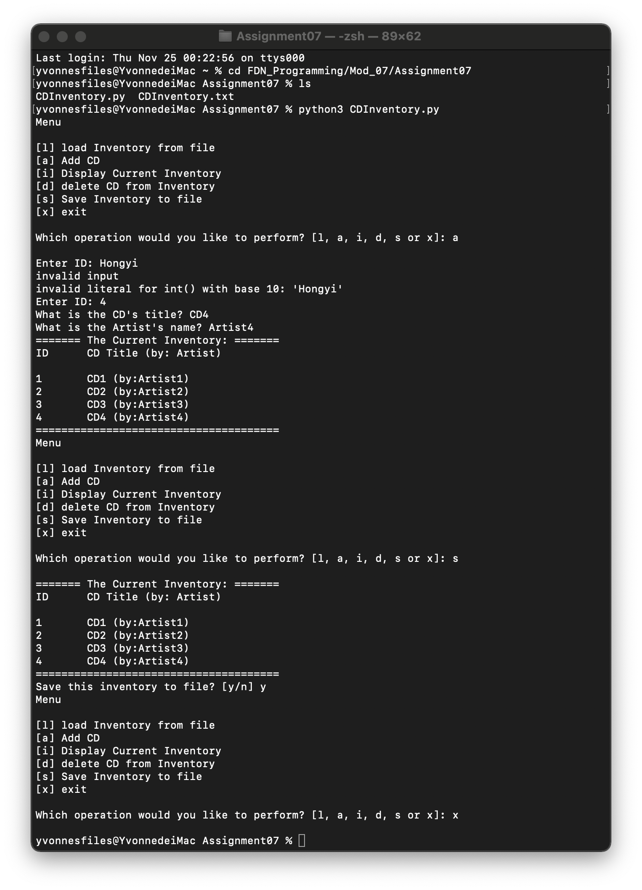

Figure 11 - Running Results of Testing ID Integer and Commands in Terminal

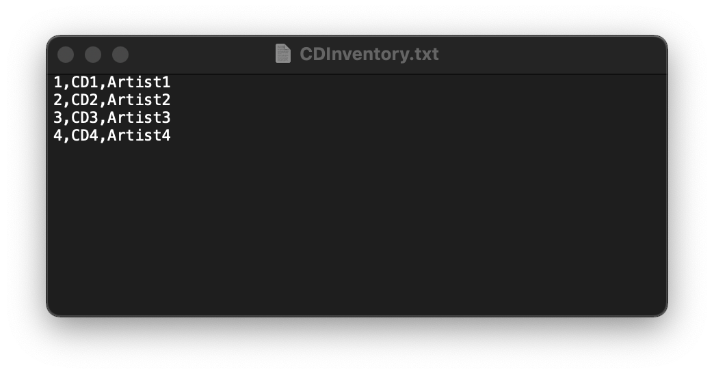

Figure 12 - Testing Results of Adding CD in CDInventory.txt

Figure 13 and 14 first tested [l] load inventory from file, then [d] delete CD from inventory. Besides, when I tried to delete CD from inventory, I did not input an integer to test the “try-except” block in script. When I inputted “Yvonne”, it occurred an error and asked “Which ID would you like to delete?” again until I entered an existing integer. Then I tested [s] save inventory to file and [x] exit.

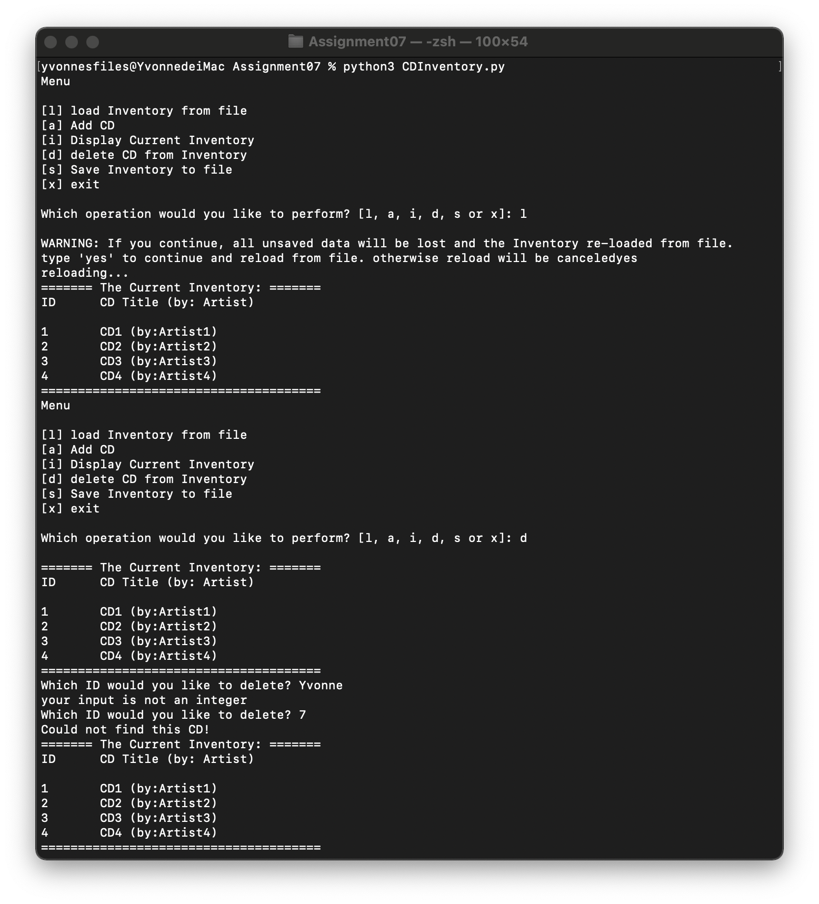

Figure 13 - Running Results of Testing Deleting an Existing CD in Terminal

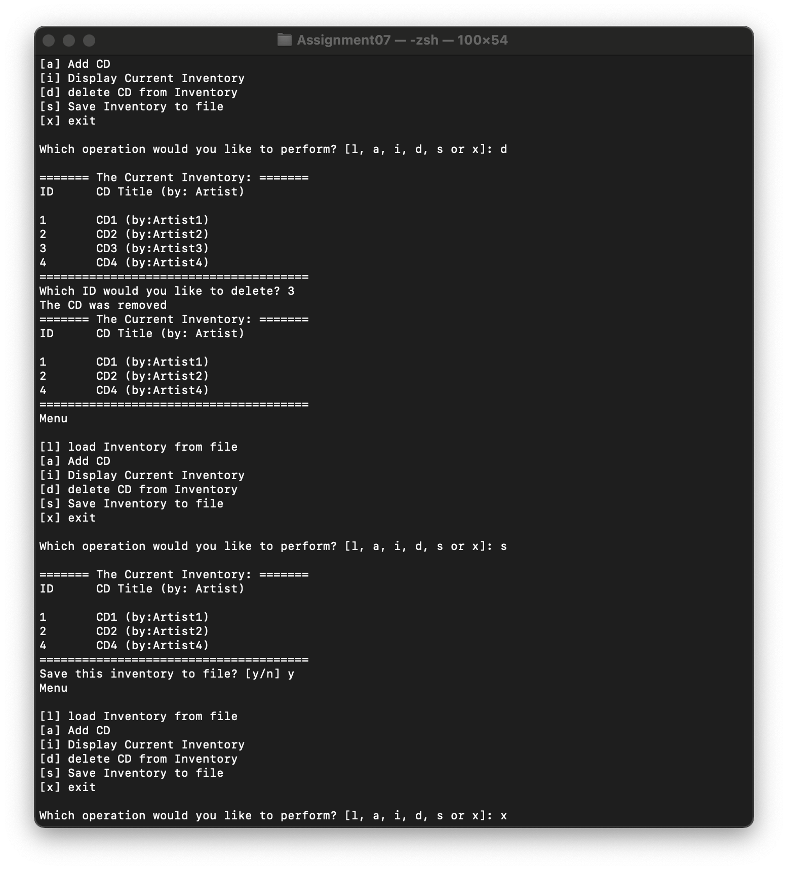

Figure 14 - Running Results of Testing Deleting an Existing CD in Terminal (Continue)

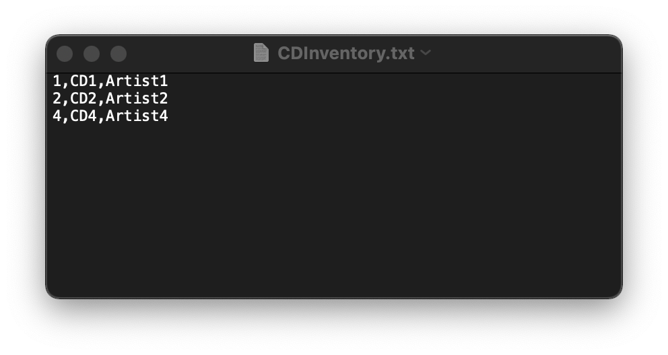

Figure 15 - Testing Results of Deleting CD Shown in CDInventory.txt

I tested the “FileNotFound” error in Figure 16 and 17. I first changed the name of txt file from “CDInventory.txt” to “CDInventory_001.txt”. Then I tried to run the script in terminal and it said “invalid filename” error.

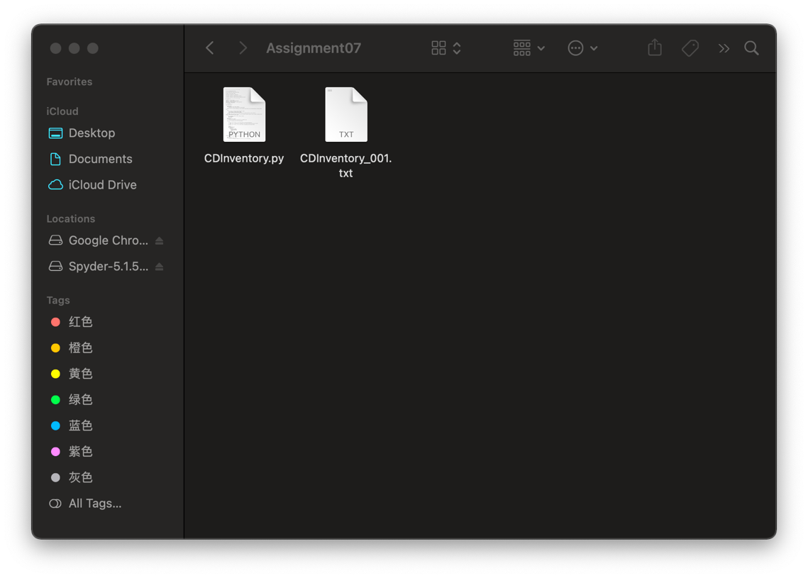

Figure 16 - Changing txt Name in Folder

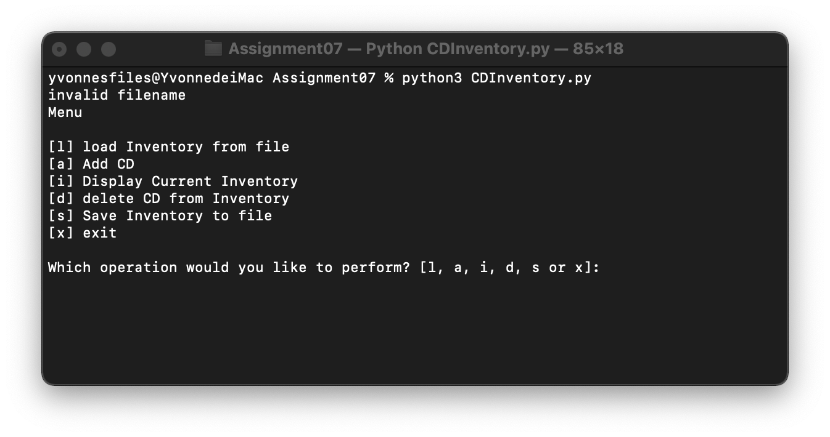

Figure 17 - Testing Results of "FileNotFound" Error in Terminal

I tested the “try-except” construction of Line 49-56 in Figure 18 and 19. I changed the CD number from “4” to “HongyiZhu” in txt file and let it run in spyder. It said “invalid line, please modify the ID as integer” as an error and returned to menu.

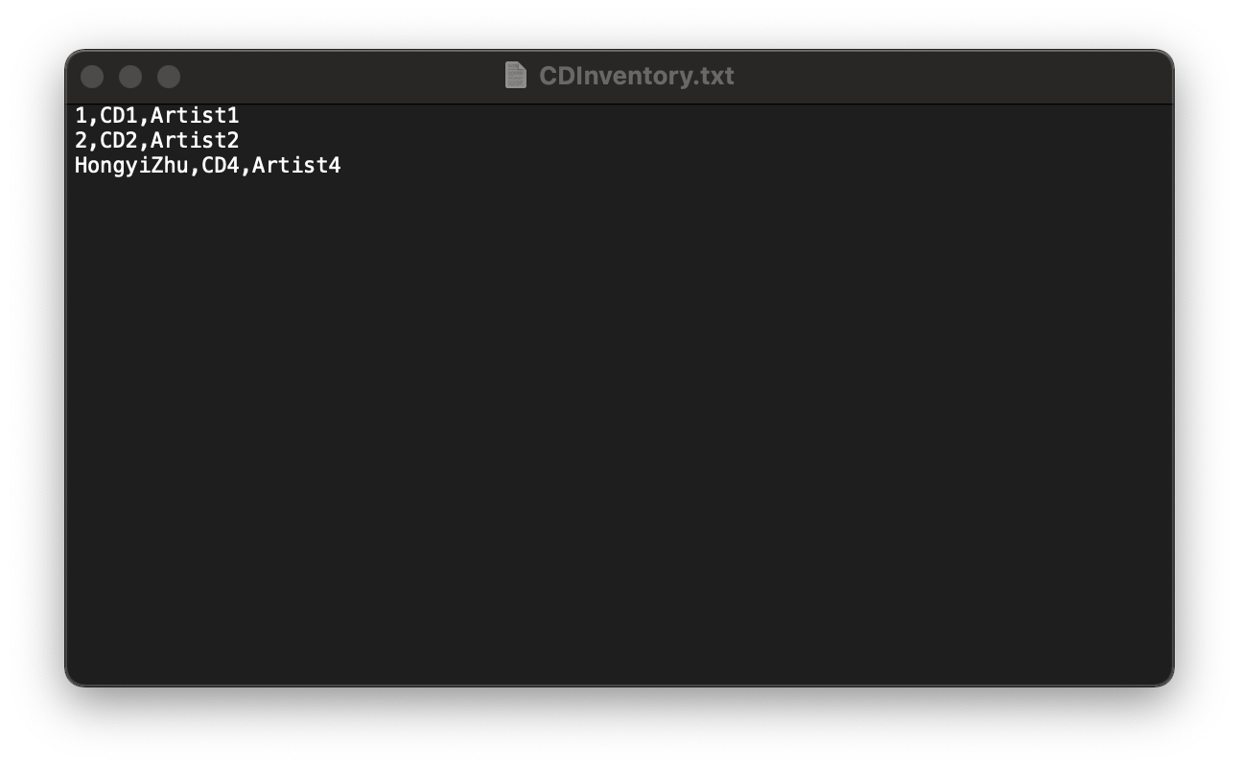

Figure 18 - Changing ID Number in txt

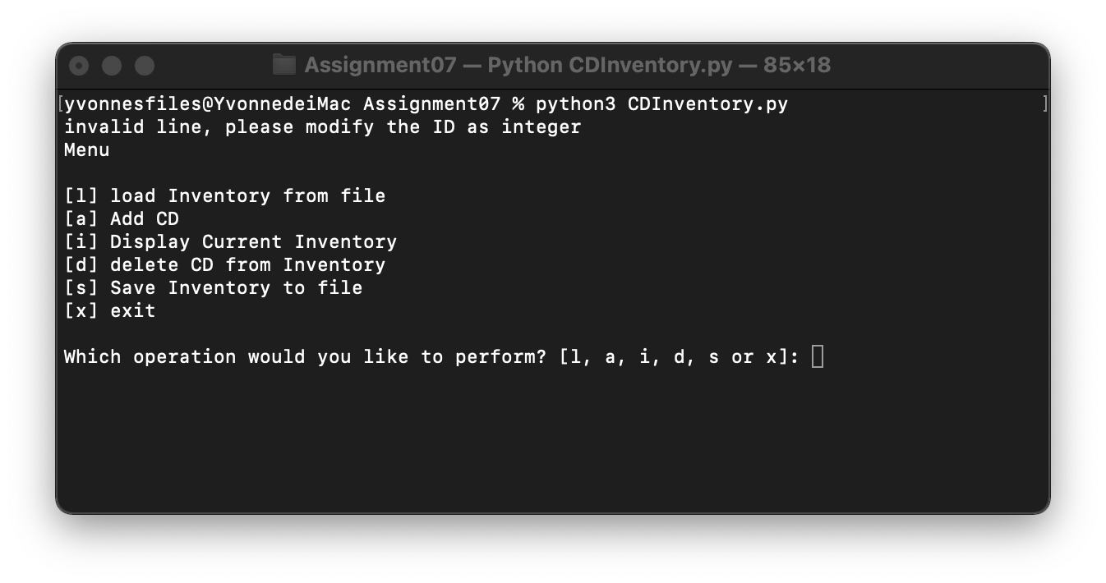

Figure 19 - Testing Results of "ValueError" in Terminal

# Summary

In this assignment, I worked with the text files and used several Structured Error Handling to make the existing program behave in a more desired way in case of Exceptions.

# Appendix

# Listing CDInventory.py

1. #------------------------------------------#
3. # Title: Assignment06_Starter.py
5. # Desc: Working with classes and functions.
7. # Change Log: (Who, When, What)
9. # DBiesinger, 2030-Jan-01, Created File
11. # HongyiZhu, 2021-Nov-21, Added Contents into File
13. # HongyiZhu, 2021-Nov-26, Added Try-Except Constructs into File
15. #------------------------------------------#
16. # -- DATA -- #
18. strChoice = '' # User input
19. lstTbl = []  # list of lists to hold data
20. dicRow = {}  # list of data row
21. strFileName = 'CDInventory.txt'  # data storage file
22. objFile = None  # file object
24. # -- PROCESSING -- #
26. class DataProcessor:
28. @staticmethod
29. def add_item(ID, Title, Artist, table):
30. """Function to add a new item into the existed table.
32. Combines the user’s input including (1) ID (2) CD name (3) CD artist to a dict and then add it into the existed table
34. Args:
35. ID (string): an integer string of the user’s input;
36. Title (string): a string of user’s input
37. Artist (string): a string of user’s input
38. table (list of dicts): a list of dicts (the dicts include 3 key(‘ID’,’Title’,’Artist’))
39. Returns:
40. table (new list of dicts): a list of dicts (the dicts include 3 key(‘ID’,’Title’,’Artist’)) which has been added the new item from the user’s input.
41. """
42. dic = {'ID': ID, 'Title': Title, 'Artist': Artist}
43. table.append(dic)
44. return table
46. @staticmethod
47. def delete_item(table,IDDel):
48. """Function to delete the item whose ID is provided by user.
50. Delete the corresponding item of the existed table.
52. Args:
53. table (list of dicts): a list of dicts which is the existed CDInventory
54. IDDel (int): an integer which corresponds to the ID that the item the user wants to delete
55. Returns:
56. table (list of dicts): a list of dicts whose corresponding item has been deleted.
57. """
59. intRowNr = -1
60. blnCDRemoved = False
61. for row in table:
62. intRowNr += 1
63. if row['ID'] == IDDel:
64. del table[intRowNr]
65. blnCDRemoved = True
66. break
68. if blnCDRemoved:
69. print('The CD was removed')
70. else:
71. print('Could not find this CD!')
72. return table
74. class FileProcessor:
75. """Processing the data to and from text file"""
77. @staticmethod
78. def read_file(file_name, table):
79. """Function to manage data ingestion from file to a list of dictionaries
81. Reads the data from file identified by file_name into a 2D table
82. (list of dicts) table one line in the file represents one dictionary row in table.
84. If the file gets removed or does not exist at all, then the “FileNotFound” error will occur and the program will return to menu.
86. In the first column of CDInventory.txt text file, if the ID number here is not an integer, Line 105 'ID': int(data[0]) will have the “ValueError”.
87. “Try-except” construction can handle the error and print “invalid line, please modify the ID as integer”, then return to menu.
89. Args:
90. file_name (string): name of file used to read the data from
91. table (list of dict): 2D data structure (list of dicts) that holds the data during runtime
93. Returns:
94. None.
95. """
96. table.clear()  # this clears existing data and allows to load data from file
97. try:
98. objFile = open(file_name, 'r')
99. except:
100. print('invalid filename')
101. return
102. for line in objFile:
103. try:
104. data = line.strip().split(',')
105. dicRow = {'ID': int(data[0]), 'Title': data[1], 'Artist': data[2]}
106. table.append(dicRow)
107. except:
108. print('invalid line, please modify the ID as integer')
109. objFile.close()
110. return
111. objFile.close()
112. @staticmethod
113. def write_file(file_name, table):
114. """Function to write the table to the file.
116. Args:
117. file_name (string): an string which is the file name that the user want to use for saving the data.
118. table (list of dicts): a list of dicts which is the existed CDInventory
119. Returns:
120. None.
121. """
123. objFile = open(file_name, 'w')
125. for row in table:
126. lstValues = list(row.values())
127. lstValues[0] = str(lstValues[0])
128. objFile.write(','.join(lstValues) + '\n')
129. objFile.close()
131. class IO:
132. """Handling Input / Output"""
133. @staticmethod
134. def print_menu():
135. """Displays a menu of choices to the user
137. Args:
138. None.
140. Returns:
141. None.
142. """
143. print('Menu\n\n[l] load Inventory from file\n[a] Add CD\n[i] Display Current Inventory')
144. print('[d] delete CD from Inventory\n[s] Save Inventory to file\n[x] exit\n')
146. @staticmethod
147. def menu_choice():
148. """Gets user input for menu selection
150. Args:
151. None.
153. Returns:
154. choice (string): a lower case sting of the users input out of the choices l, a, i, d, s or x
156. """
157. choice = ' '
158. while choice not in ['l', 'a', 'i', 'd', 's', 'x']:
159. choice = input('Which operation would you like to perform? [l, a, i, d, s or x]: ').lower().strip()
160. print()  # Add extra space for layout
161. return choice
163. @staticmethod
164. def show_inventory(table):
165. """Displays current inventory table

168. Args:
169. table (list of dict): 2D data structure (list of dicts) that holds the data during runtime.
171. Returns:
172. None.
174. """
175. print('======= The Current Inventory: =======')
176. print('ID\tCD Title (by: Artist)\n')
177. for row in table:
178. print('{}\t{} (by:{})'.format(*row.values()))
179. print('======================================')
181. @staticmethod
182. def ask_newID():
183. """Function to ask user to input a new item.
185. Receives the input from user including (1) ID (2) CD name (3) CD artist.
187. If the user’s input is not an integer, then it is a “ValueError” and will print out “invalid input” and does not terminate the program.
189. When an ID is to be deleted, if the input is not an integer, line 248 “intIDDel = int(strIDDel)” will occur the “ValueError”.
190. “Try-except” block will handle the error, printing “your input is not an integer”.
192. Args:
193. None
194. Returns:
195. strID (string): an integer string of the user’s input;
196. strTitle (string): a string of the user’s input;
197. stArtist (string): a string of the user’s input.
198. """
200. while True:
201. strID = input('Enter ID: ').strip()
202. try:
203. intID = int(strID)
204. break
205. except ValueError as e:
206. print('invalid input')
207. print(e)
208. strTitle = input('What is the CD\'s title? ').strip()
209. stArtist = input('What is the Artist\'s name? ').strip()
210. return intID, strTitle, stArtist
212. FileProcessor.read_file(strFileName, lstTbl)
214. while True:
215. IO.print_menu()
216. strChoice = IO.menu_choice()
218. if strChoice == 'x':
219. break
221. if strChoice == 'l':
222. print('WARNING: If you continue, all unsaved data will be lost and the Inventory re-loaded from file.')
223. strYesNo = input('type \'yes\' to continue and reload from file. otherwise reload will be canceled')
224. if strYesNo.lower() == 'yes':
225. print('reloading...')
226. FileProcessor.read_file(strFileName, lstTbl)
227. IO.show_inventory(lstTbl)
228. else:
229. input('canceling... Inventory data NOT reloaded. Press [ENTER] to continue to the menu.')
230. IO.show_inventory(lstTbl)
231. continue  # start loop back at top.
233. elif strChoice == 'a':
234. strID, strTitle, stArtist = IO.ask_newID()
235. lstTbl = DataProcessor.add_item(strID, strTitle, stArtist, lstTbl)
236. IO.show_inventory(lstTbl)
237. continue  # start loop back at top.
239. elif strChoice == 'i':
240. IO.show_inventory(lstTbl)
241. continue  # start loop back at top.
243. elif strChoice == 'd':
244. IO.show_inventory(lstTbl)
245. while True:
246. strIDDel = input('Which ID would you like to delete? ').strip()
247. try:
248. intIDDel = int(strIDDel)
249. break
250. except:
251. print('your input is not an integer')
252. lstTbl = DataProcessor.delete_item(lstTbl, intIDDel)
253. IO.show_inventory(lstTbl)
254. continue  # start loop back at top.
256. elif strChoice == 's':
257. IO.show_inventory(lstTbl)
258. strYesNo = input('Save this inventory to file? [y/n] ').strip().lower()
259. if strYesNo == 'y':
260. FileProcessor.write_file(strFileName, lstTbl)
261. else:
262. input('The inventory was NOT saved to file. Press [ENTER] to return to the menu.')
263. continue  # start loop back at top.
265. else:
266. print('General Error')

1. Retrieved 2021-Nov-26